Google Gems hands on
Exercise 1: First Login; Plan Check
Difficulty: Beginner
Scenario
You are a new Gemini user. Your goal is to log in, identify your current plan, and get
comfortable with the interface before doing anything else.
Step-by-Step Instructions
1. Open gemini.google.com in your browser.
2. Check whether you are automatically signed in using your Google account.
3. Look at the background colour — white means Free plan, black means Pro plan.
4. Locate the prompt box at the bottom of the screen.
5. Type your very first message: What can you help me with today?;
6. Read the response and note the range of capabilities Gemini lists.

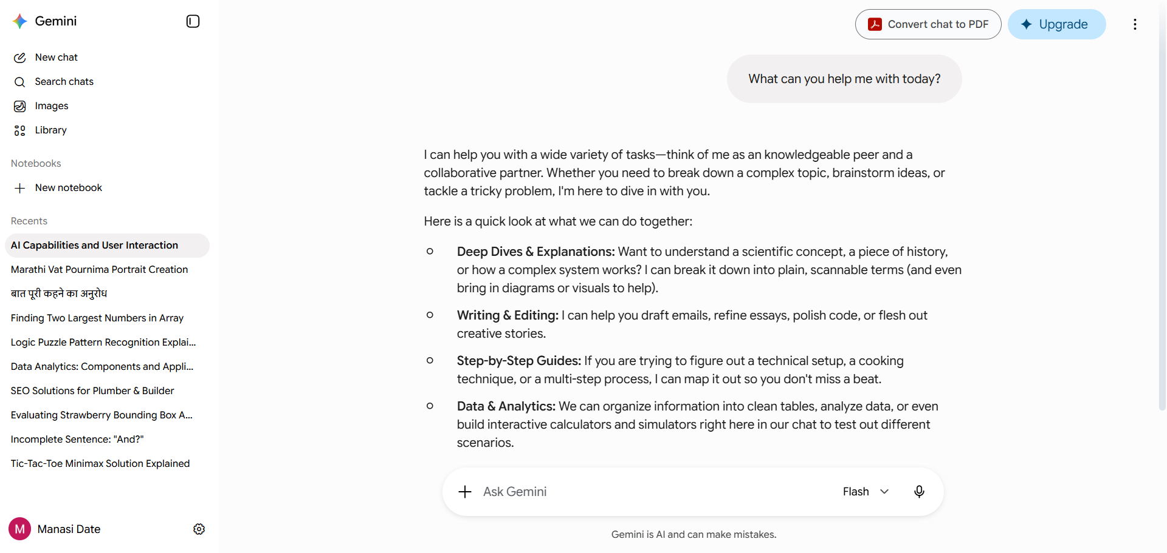

Exercise 2: Set Your Custom Instructions
Difficulty: Beginner
Scenario
You want Gemini to know you are a small business owner who uses Android and prefers
concise, bullet-point answers. You will configure this once so it applies to every future
conversation.
Step-by-Step Instructions
1. Open Gemini Settings using the gear icon.
2. Navigate to the ;Custom Instructions; section.
3. In the About you; field, write: ;I;m a small business owner. I use an Android phone and a
Windows laptop
4. In the Response style; field, write: ;Give me concise answers using bullet points. Keep
examples practical and business-relevant.;
5. Save your instructions.
6. Test it immediately: Ask ;How can I improve my customer response time?;
7. Evaluate: Are the answers in bullet points? Do they avoid Apple or Mac-specific advice?
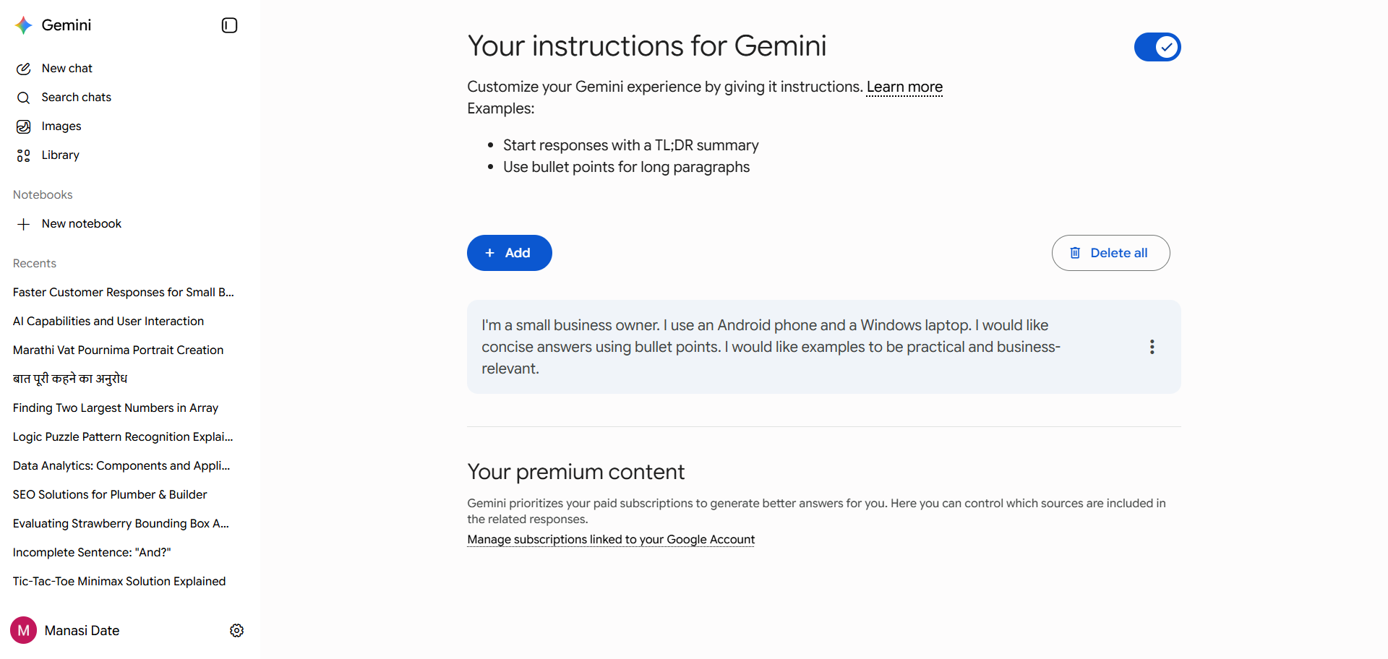
Output:

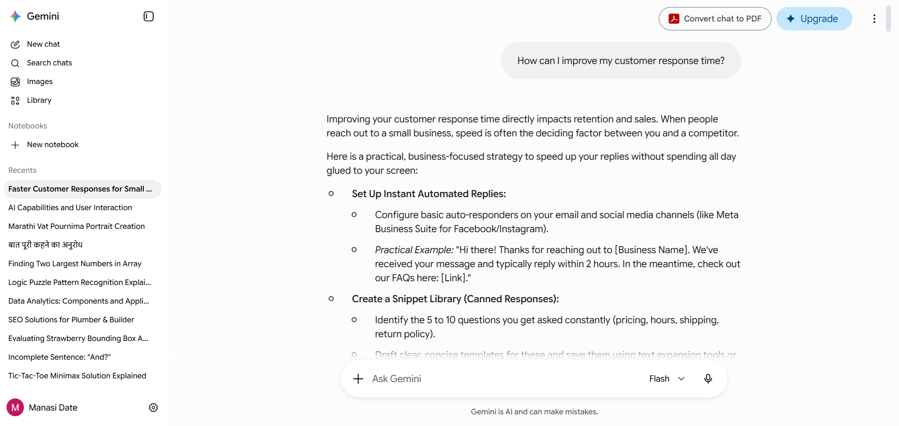

Exercise 3: Normal Chat vs Temporary Chat
Difficulty: Beginner
Scenario
You want to clearly understand the difference between standard chat (saved history) and
Temporary Chat (incognito mode), and know when to use each.
Step-by-Step Instructions
1. Start a New Chat from the main interface.
2. Ask: ‘Give me 3 tips for better sleep.’
3. After the response, check your chat history on the left sidebar — this conversation
should appear.
4. Now start a Temporary Chat using the menu option.
5. Ask the exact same question: ‘Give me 3 tips for better sleep.’;
6. After the response, return to your chat history — the temporary conversation should
NOT appear there.
7. Reflect and write down: In what situations would you choose Temporary Chat? (e.g.,
health questions, confidential business topics, sensitive research)
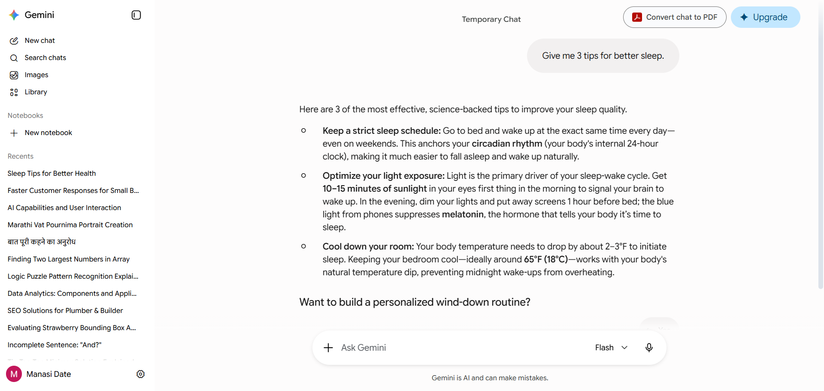

Chat History: Temporary Chat not shown .
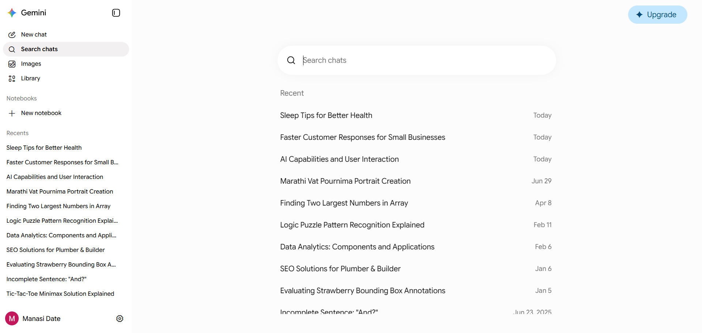

Exercise 4: Edit Your Last Prompt
Difficulty: Intermediate
Scenario
You asked Gemini a question but the response was too long and detailed. Instead of starting a
new chat, you use the prompt editing feature to refine your request.
Step-by-Step Instructions
1. Ask Gemini: ;Explain how solar panels work.;
2. Read the response — it is likely very detailed and lengthy.
3. Scroll up to your original message and click the edit icon (pencil symbol).
4. Change your prompt to: ;Explain how solar panels work in exactly 3 sentences.;
5. Submit the edited prompt and compare the two responses side by side.
6. Edit again: Change the prompt to ;Explain how solar panels work using an analogy a 10-
year-old would understand.;
7. Reflect: How does editing prompts save time compared to starting a new conversation?

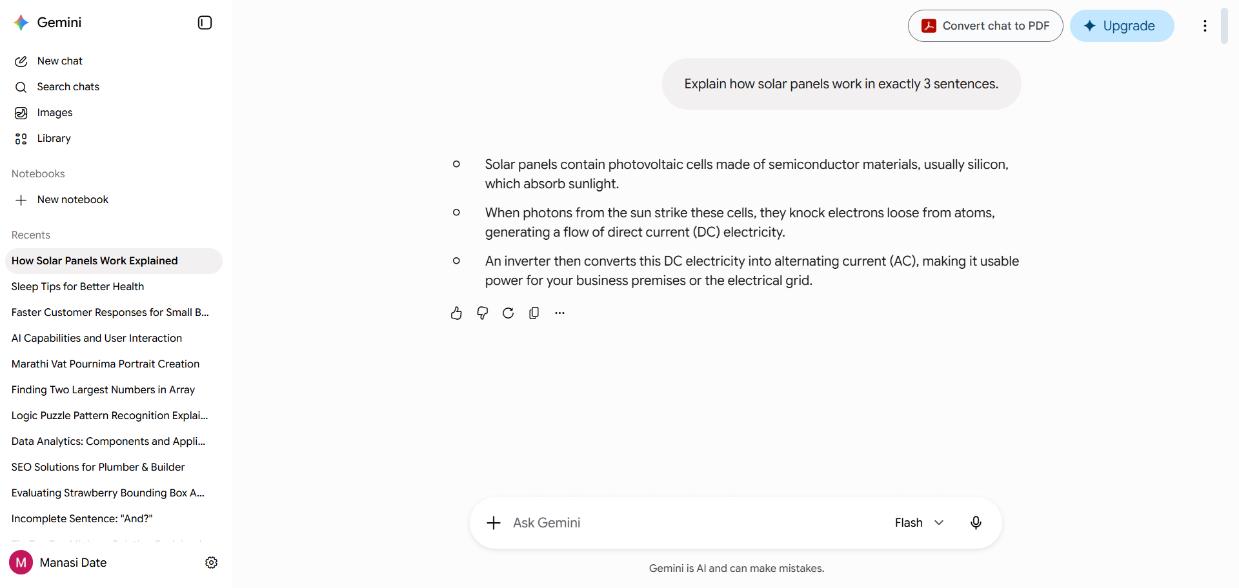

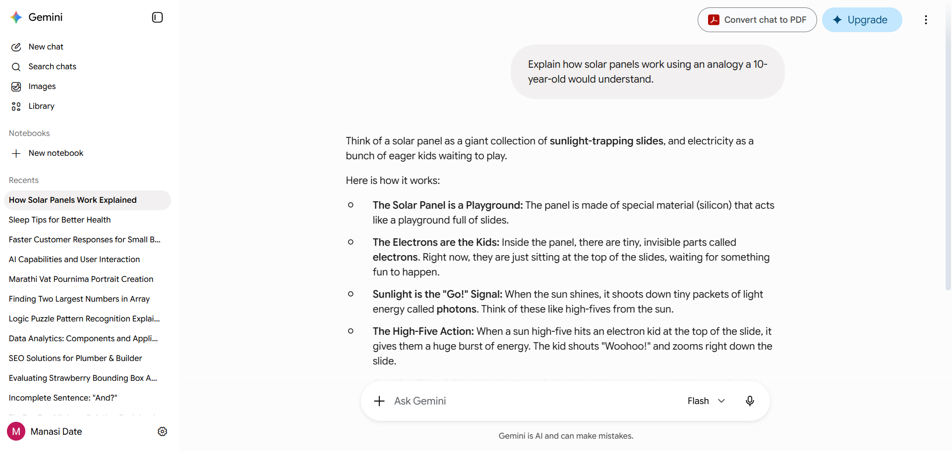

How does editing prompts save time compared to starting a new conversation?
Ans: • No Re-Typing: You don't have to re-explain your business, target audience, or goals.
• Instant Course-Correction: If the AI goes off-track, editing slices off the bad tangent and forces it to regenerate from that exact moment.
• Retains Instructions: It remembers your preferred formatting, tone, and length constraints without you having to restate them.

Exercise 5: Connect Google Apps; Ask a Personal Question
Difficulty: Intermediate
Scenario
You want Gemini to act as a true personal assistant by accessing your real Gmail inbox —
demonstrating the difference between a search engine and a personal AI.
Step-by-Step Instructions
1. Go to Gemini Settings and find the Extensions section.
2. Enable the Google Workspace extension (grants access to Gmail and Google Drive).
3. Return to a new chat and type: ‘Summarise the last 3 emails in my Gmail inbox using
@Gmail’;
4. Observe how Gemini accesses and reads your live inbox data.
5. Follow up: ;Draft a polite, professional reply to the most recent email.;
6. Review the draft: Does it reflect the correct sender, subject, and appropriate tone?
7. Reflect: How is this different from searching your inbox manually?
1.Saves Time (No "Context Switching"): Instead of clicking into three separate emails, reading through formal greetings, signatures, and legal footers, you get the core message instantly in one view.
2.Automatic Prioritization: The AI extracts the "bottom line" (e.g., an invoice amount, an action item like a client wanting a call, or a specific delivery date) so you can immediately decide what needs your attention right now versus what can wait.
3.High-Level Tracking: If you are on the go using your Android phone, skimming a bulleted summary is much easier than pinching and zooming to read dense email threads or tracking updates.

